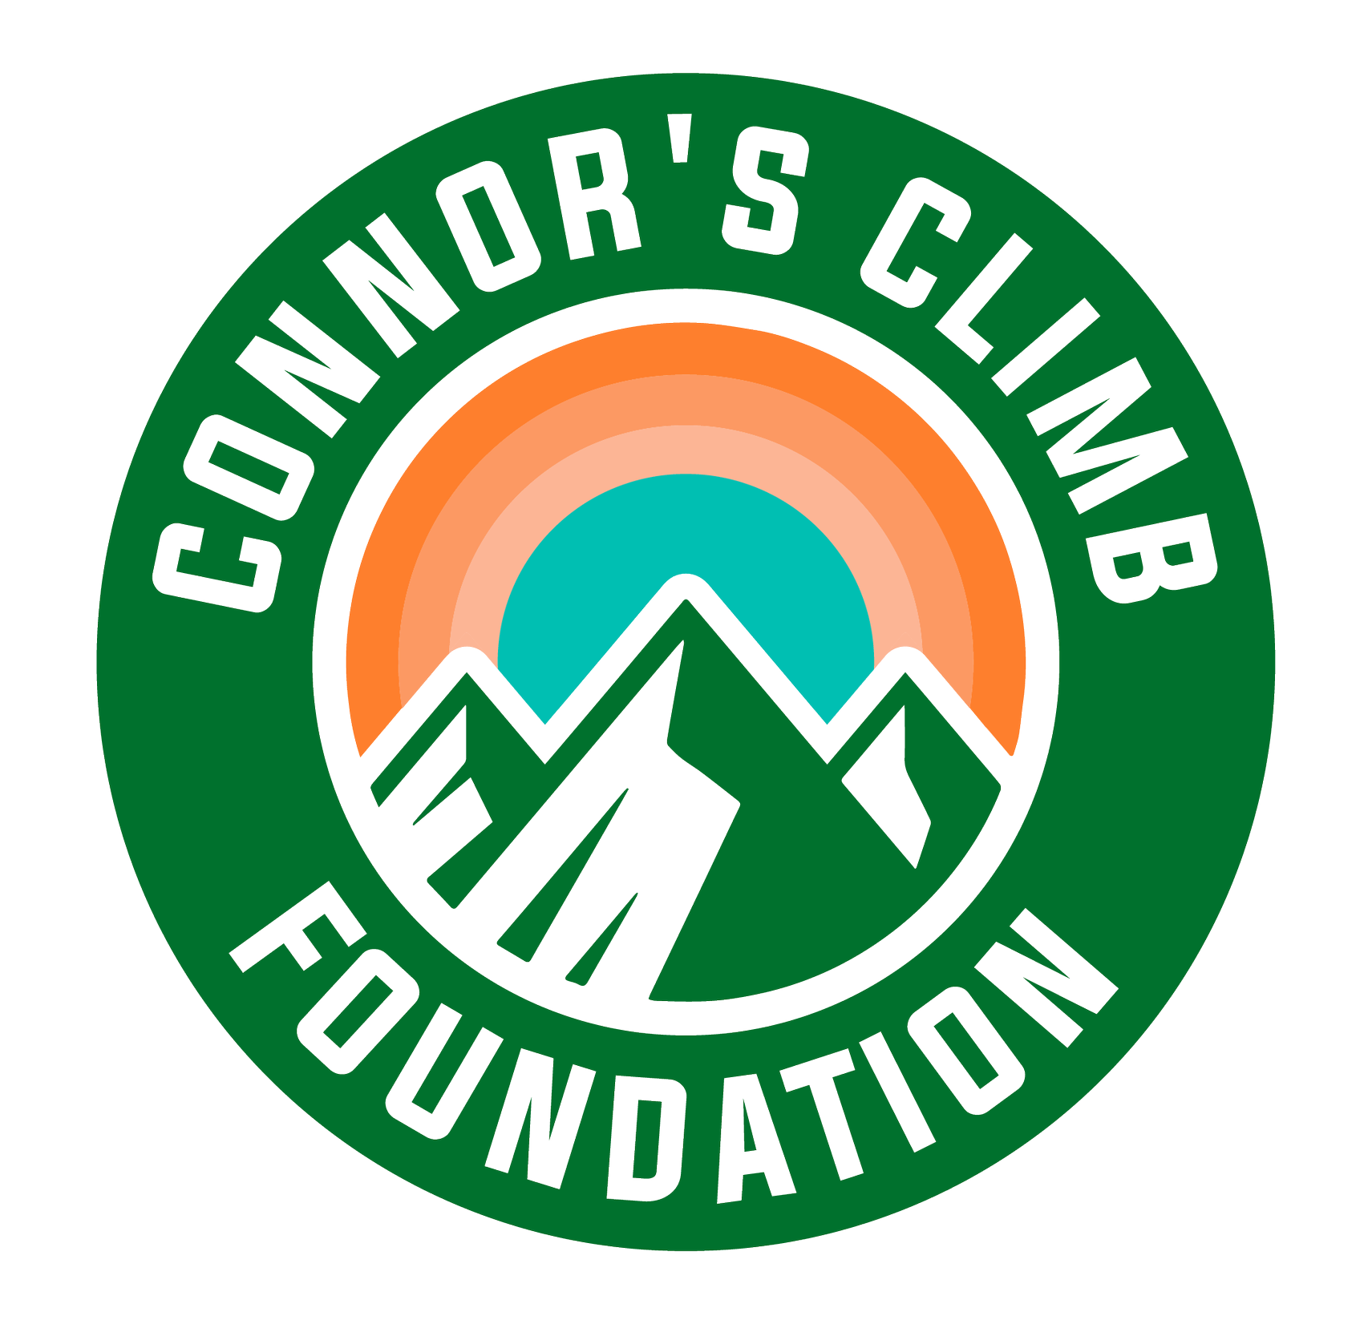
SOS Signs of Suicide:
Training Trusted Adults (Parents & Community)

In-Person Event: Thursday, September 28, 2023
Hampton Academy - Auditorium

7:00pm - 8:00pm

Presented by Connor’s Climb Foundation:

Sarah Gould, Training & Program Coordinator

Training Trusted Adults - Agenda

Youth suicide prevention basics

ACT (Acknowledge, Care, Tell)

What to do when your child ACTs

Building coping skills

Resources

Additional Resources Resources:
SOS Signs of Suicide Parent Portal (provides resources and an overview of the SOS Program)
Article: How Can Parents Help Kids Help a Friend?

NH lawmakers passed Senate Bill 282. RSA 193-J codifies suicide prevention education

