!8157-NCH!

Virginia M. Barry, Ph.D.  Commissioner of Education  Tel. 603-271-3144 | 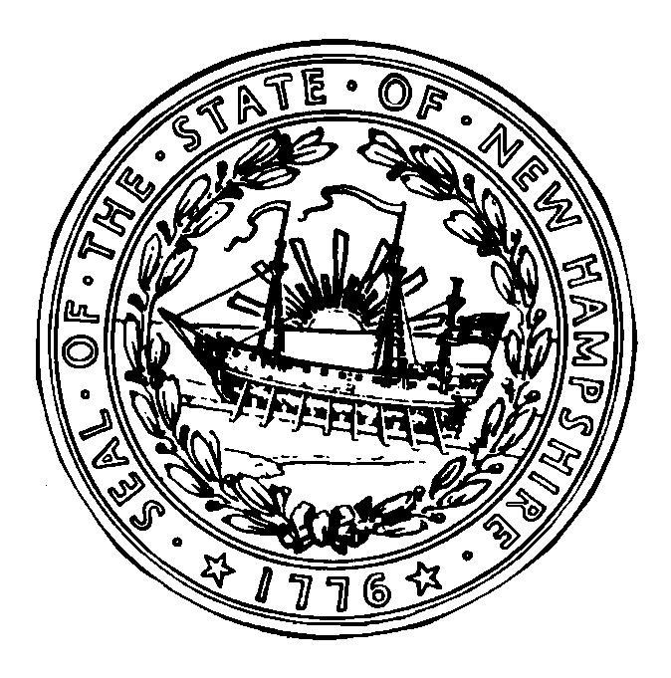 | Paul Leather  Deputy Commissioner  Tel. 603-271-7301
 | STATE OF NEW HAMPSHIRE  DEPARTMENT OF EDUCATION  101 Pleasant Street  Concord, N.H. 03301  Citizens Services Line 1-800-339-9900 | Contact:  Bureau of Credentialing  101 Pleasant Street  Concord, NH 03301  Tel: 271-2409  Fax: 271-4134

Name / Address Change Form

~ ~ ALL HIGHLIGHTED AREAS ARE REQUIRED TO BE COMPLETED ~ ~

Date:
*Social Security Number: |  |  |  | OR |  | Teacher #:
I have changed my: |  |  | Name

(check appropriate box)
 |  | former name on file is:
 |  |  |  |  | (please PRINT)
 |  |  | Address
 |  |  | Telephone number

*New Name:

*New Mailing Address:
 |  | (Mailing Address)

To be used for statistical purposes only:

______ American Indian

______ Asian/PAC

______ Black/Non Hispanic

______ White/Non Hispanic

______ Hispanic
 |  | City State Zip code
 |  | ( )

*New Telephone number:
*Alternative Telephone: |  | ( )

*email address:

*Alternate email address:

*Printed Name:
 |  |  |  |  |  |  | Date Submitted:

*Signature:

Updated: January 2013

